

**The Global Outlook**

Speech given by Mark Carney

Governor of the Bank of England

Financial Times event in Frobisher Hall, the Barbican 12 February 2019

I am grateful to Clare Macallan, Daisy McGregor and James Benford for their assistance in preparing these remarks, and to Thomas Viegas, Cian O’Neill, Ambrogio Cesa-Bianchi, Jon Bridges, Simon Whitaker, Emil Iordanov, Anina Thiel and Robert Gilhooly for background research and analysis.

It sometimes seems that everything in our world is connected.

It is a pleasure to meet in Frobisher Hall today. This hall is named after Sir Martin Frobisher, an English navigator who explored Canada’s eastern arctic coast in the 16th century in search of new trade routes.

His connection to the Barbican is that most of him is buried in the St Giles-in-the-Fields churchyard. (His heart and entrails are in St Andrew’s Church in Plymouth).

Martin Frobisher is perhaps more famous in Canada than in his native land. One of the great bays in the eastern arctic is named after him. The capital of Nunavut, Iqaluit, lies at the innermost end of Frobisher Bay.

Nine years ago this month Iqaluit hosted the G7 meeting that marked the start of the euro crisis. Events that still reverberate today including in the environs of the Barbican.

While the debate in the United Kingdom has been understandably dominated by Brexit, the world has been otherwise engaged.

When the Referendum was being held, the global economy was emerging from a long period of financial repair and lacklustre growth. Over the subsequent two years, a widespread and increasingly vigorous global expansion took hold. For the first time since the financial crisis, business investment and foreign trade grew strongly across all major regions. Economic uncertainty diminished, and consumer and business confidence firmed. In economies close to full employment, real wages finally began to grow.

A new beginning seemed possible.

In the past few quarters, however, these trends have largely reversed. After peaking a year ago around 4%, global momentum is now weakening in all major regions and downside risks have intensified. The proportion of the global economy growing above trend has fallen from four-fifths to one-third. Trade growth has slowed and the export outlook has dimmed. Capital goods orders are stagnating, investment growth has become more tepid, and business confidence is diminished (**Chart 1**).

**Chart 1:** Global momentum is weakening

Index, amplitude adjusted, Long-term average=100 102

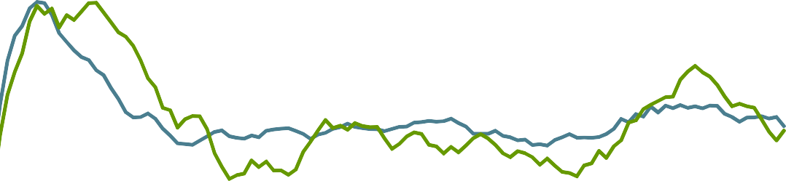

OECD Business confidence

World trade in goods

US & EA capital goods orders

Percentage change, 3 months on 12 months ago

20

15

101 10

5

100

99

2010 2011 2012 2013 2014 2015 2016 2017 2018

Sources: ECB, Conference Board, CPB, OECD, and Markit Economics and Bank calculations.

0

-5

-10

In part, the deceleration of the global economy reflects the shift from accommodative to tighter financial conditions that occurred initially in emerging economies, then in most advanced economies, and finally and sharply in the United States (**Chart 2**). Last year, the returns on all major asset classes from equities to credit to sovereign debt were negative. Cash once again was king.

**Chart 2**: Global financial conditions indices tightened over 2018

United Kingdom United States

Emerging Market Economies Global

Standard deviations from historical average 8

# 7

6

5

4

3

2

1

0

-1

-2

## 2007 2008 2009 2010 2011 2012 2013 2014 2015 2016 2017 2018 2019

Sources: Bloomberg Finance L.P., Eikon by Refinitiv and Bank calculations.

The tightening of financial conditions globally partly reflected the usual – if somewhat delayed – reaction to the tightening of monetary policy.1 Over the past year, the withdrawal of monetary policy accommodation gathered pace. The Fed raised interest rates four times, and the Bank of England and ten other G20 central banks also tightened policy. In addition, after five years in which there was no new net issuance of G7 government debt, new government borrowing outweighed central bank purchases by more than $1 trillion for the first time since 2012.

Potentially more seriously, the slowing in global momentum may also be the product of rising trade tensions and growing policy uncertainty. Global economic policy uncertainty is at record highs (**Chart 3**). And protectionist rhetoric is becoming reality, with the United States raising tariffs on a range of imports from its main trading partners, and some retaliating in kind (see Annex **Table A1**). If all measures contemplated are implemented, average US tariffs will reach rates not seen in half a century.

1 Overall, financial conditions in the US have tightened by around half a standard deviation over the course the current tightening cycle thus far (**Chart 2**). This is a similar cumulative increase as in the 2004-06 tightening cycle, though somewhat less than in the cycle at the turn of the millennium – a pattern is broadly mirrored across advanced economies more generally.

**Chart 3**: Indices of global economic policy uncertainty are at record highs

## 5

Standard deviations from historical average

4

3

2

1

0

-1

-2

1997 1999 2001 2003 2005 2007 2009 2011 2013 2015 2017

Sources: Bloom et al (2015)2 and Bank calculations

Given the confluence of the current broad-based slowdown and outstanding downside risks, some are beginning to wonder whether the global expansion, begun in 2010, could be starting to end.

Recessions are notoriously difficult to predict. The IMF has anticipated only a sixth of the over 300 recessions in member countries since 1991. Financial markets are more likely to cry wolf, making Paul Samuelson’s observation fifty years ago that “*the stock market has predicted nine of the past five recessions”* as relevant today as it was then.3 For what it is worth, market-implied probabilities of a recession in the US are around 20%, nearly three times higher relative to this time a year ago (**Chart 4**).

There are multiple definitions of what constitutes a global recession. Some have used a benchmark of global GDP growth falling below 2½% or 3%, whilst the IMF uses a definition of a fall in global GDP per capita.4 On the IMF’s definition, there have been four global recessions since WWII: in 1975, 1982, 1991 and 2009.

2 See: Baker, S, Bloom, N and Davis, S (2015) Measuring economic policy uncertainty, NBER Working Paper No.21633

3 From Samuelson’s 1966 column ‘Science and Stocks’ in *Newsweek*.

4 This is equivalent to global GDP growth falling below the current rate of population growth of 1%.

**Chart 4**: Market-implied probabilities of a US recession have risen

Per cent

1973 1978 1983 1988 1993 1998 2003 2008 2013 2018

100

90

80

70

60

50

40

30

20

10

0

NBER recessions Fed recession indicator

Sources: Federal Reserve Board; NBER.

Notes: For methodology see Favara, G, Gilchrist, S, Lewis, K F, Zakrajsek, E (2016) *Recession Risk and the Excess Bond Premium*, FEDS Notes, Board of Governors of the Federal Reserve System.

To assess whether recent global developments represent a soft patch or herald renewed stagnation, it is helpful to consider the position of the global economy with respect to three interrelated cycles: the business cycle, the financial cycle and the cycle of globalisation.

In each cycle, imbalances can build that hasten their demise, so I will focus on a few of the most important imbalances to assess global prospects.

### The Business Cycle

The business cycle tracks fluctuations in demand about the supply potential of the economy. In the expansion phase, growth in output exceeds that of the economy’s supply capacity. As a result, costs rise more quickly as companies use resources more intensively, putting upward pressure on inflation. When output growth falls below potential, the opposite occurs. Business cycles have historically lasted up to eight years on average across advanced economies.5 Recent experience suggests the expansionary phase is getting longer, and the downturn shorter, partly because of the greater credibility of monetary policy.6

5 In the UK and US, the average duration has been 5 ½ years, based respectively on Hills et al (2010) and the National Bureau of Economic Research’s business cycle dating committee [(http://www.nber.org/cycles.html).](http://www.nber.org/cycles.html))

6 See, for example, Miles, D, Panizza,U, Reis, R and Ubide, A (2017) ‘And Yet It Moves. Inflation and the Great Moderation’, Geneva Reports on the World Economy 19.

Business cycles can be first amplified and then imperilled by growing imbalances in the real economy, such as over-investment in capital and housing, debt-fuelled consumption, or, particularly in emerging economies, excess current account imbalances that can lead to sudden stops.7

And imbalances can manifest themselves in rising inflation. In those advanced economies closest to full employment like the US and the UK, wage pressures have picked up as slack has been absorbed. A similar pattern is observable in the euro area (**Chart 5**). In the UK, private sector wage growth has increased from around 1% five years ago, to 2% 3 years ago; 2½% last year to 3 ½ % today as unemployment has fallen below its natural rate.

**Chart 5**: Wage pressures are building in advanced economies as slack is absorbed



3.5 Four-quarter wage growth (per cent)

3.0

**UK**

Darkest values are 2018

2.5

**US**

2.0

1.5

**Euro area**

1.0

0.5

Lightest values are 2013

0.0

3.0

4.0

5.0

6.0

7.0

8.0

9.0

10.0 11.0 12.0

Unemployment rate (per cent)

Sources: ONS, Eurostat, Bureau of Labor Statistics, and Bank Calculations

Notes: The UK wage measure is Average Weekly Earnings (AWE) regular pay, the US wage measure is Employment Cost Index (ECI) wages & salaries, and the EA wage measure is compensation per employee. Data frequency is quarterly.

The recent Anglo Saxon experience suggests the wage Phillips Curve is alive and well, if not particularly steeply sloped. The pick-up of wages is slowly feeding through to core inflation, which is now close to 2% in both the US and UK.

Globally, inflation has moderated as commodity prices have fallen back, consistent with the slower pace of global growth, and some evidence of slack emerging in a range of economies.

7 Such imbalances can themselves build up in an over-reaction to deeper phenomena such as an increase in total factor productivity growth or a temporary surge in growth in the workforce resulting from technological change. Such development can result in over-investment if firms and households are overoptimistic about their duration.

Financial markets now expect more accommodative than previously monetary policies in all major economic areas (**Chart 6**), and in China, the PBOC has taken a number of measures to provide stimulus.8

**Chart 6**: Financial markets expect more accommodative monetary policy than they did in 2018

Per cent

3.5



Solid lines: February 2019 *Inflation Report*

Dashed lines: November 2018 *Inflation Report*

United States

Federal funds rate

United Kingdom

Bank Rate

Euro area

ECB main refinancing rate

ECB deposit rate

3.0

2.5

2.0

1.5

1.0

0.5

0.0

-0.5

2014 2016 2018

2020 2022

-1.0

Sources: Bank of England, Bloomberg Finance L.P., ECB, Federal Reserve, Eikon from Refinitiv and Bank calculations.

Provided the expansion continues, a modest tightening of monetary policy over time will likely be sufficient to achieve inflation targets. Policy can remain limited and gradual, as well as data dependent.

Both these guides to monetary policy reflect the historically low level of the equilibrium interest rate, or r*.9 As the Bank of England has long emphasised, a number of forces have depressed r* 10 – a view that has been validated by muted inflation over the past five years, despite a long period of historically low interest rates.11 As the Federal Reserve has observed, incoming data will provide important information about the evolution of the equilibrium rate.12

8 The PBOC have introduced several easing measures since April 2018 including cuts to the reserve requirement ratio, relaxing capital requirements for banks, and introducing credit support for private businesses.

9 The equilibrium interest rate is the level of the real policy rate that, if allowed to prevail for several years, would place economic activity at its potential and keep inflation low and stable.

10 A set of profound forces in the world economy, both secular and cyclical, has pushed down on the level of world real

interest rates over the past 30 years by as much as 450 basis points - see Carney, M (2013), ‘The spirit of the season’ and Rachel, L and Smith, T (2015), ‘Secular drivers of the global real interest rate’, Bank of England Working Paper No. 571). The global equilibrium interest rate is likely to rise in coming years as some of the shorter-term factors pushing it down ease. For example, the process of private sector balance sheet repair is nearing an end and the global stance of fiscal policy is shifting from contractionary to expansionary. Any rise in potential productivity growth would also boost the equilibrium rate. The scope for the equilibrium rate to rise will also be greater if spare capacity is larger than currently estimated.

11 See Carney, M (2018), ‘Guidance, Contingencies and Brexit’.

12 For example, as explained by Richard Clarida in his speech ‘Data Dependence and US Monetary Policy’, 27 November 2018.

In the MPC’s projections published last week, the balance of headwinds to growth and more accommodative policies are expected to return global growth to around potential rates by the end of the year (**Table 1**).

**Table 1**: MPC projects global growth likely to settle around potential rates

Projections

Average

2018 2019 2020 2021

|  |  |  |  |  |  |  |
| --- | --- | --- | --- | --- | --- | --- |
|  | 1998-2007 |  |  |  |  | potential |
| PPP-weighted | 4 | 3½ | 3¼ | 3¼ | 3½ | 3½ |
| UK-weighted | 3 | 2½ | 2 | 2 | 2 | 2¼ |

Memo:

Sources: Bank of England, Eurostat, IMF World Economic Outlook (WEO), ONS, US Bureau of Economic Analysis and Bank calculations.

Notes: 2018-21 figures show annual average growth rates. Potential growth is calculated as an average from 2019-2021.

This is the most likely scenario unless there are shocks from the other two cycles.

### The Financial Cycle

The global financial crisis was a painful reminder that the business cycle is not the only source of imbalances. Indeed, imbalances at the heart of the financial cycle have been the best predictors of downturns in recent decades.

The financial cycle tracks the rise and fall in leverage and financial conditions around their sustainable levels. Compared to the business cycle, the financial cycle is greater in amplitude, slower moving and longer lasting, sometimes taking up to 20 years between peaks.

As an economy expands, risk taking increases and lending constraints are relaxed. Debt and asset prices rise, reinforcing each other. Towards the top of the cycle balance sheets appear strong but are increasingly fragile. Equity and asset valuations are flattered by mark-to-market profits. Debt sustainability is vulnerable to shocks.

At the very top irrationality sets in. Current conditions are assumed to continue forever. “House prices can only go up.” “Financial innovation reduces risk.” “Markets always clear.” People fall for the old lies and unknowingly take great risks secure in the belief that this time is different.

To find a silver lining in the storm clouds of the financial crisis, there has been an explosion of work into how best to track the financial cycle and avoid its damaging extremes.

A range of indicators are now monitored routinely by bodies, such as the Financial Policy Committee (FPC), tasked with maintaining financial stability. And many countries, including the UK, now have a range of macro-prudential tools to cut excesses off at source, before they affect wider economic prospects.

On the surface, global debt burdens are alarming. The outstanding stock of debt has almost doubled since the crisis. Public debt burdens across advanced economies have risen above 90% of GDP for the first time since WWII. Public sector debt is important for intergenerational equity, and high levels of public indebtedness tend to result in lower growth over the long run.13 But history suggests that high public debt is generally a chronic not an acute problem. Provided fiscal frameworks remain credible, public debt tends to be less informative for predicting recessions*.*

Research at the Bank of England and elsewhere finds that private sector credit growth is amongst the best early warning indicators of a downturn.14 Over half of recessions are preceded by private sector credit booms. And within advanced economies, two-thirds of private credit booms have also ended in recessions.15

As borrowers take on more debt and devote a greater share of cash flows to servicing it, they become more vulnerable to shocks. And there will always be shocks. Debt may not be the proximate cause of the crisis, but it can be the vulnerability that turns shock into slump.

At present, aggregate private financial imbalances in advanced economies do not appear large enough, on their own, to tip global activity from slowing to stalling. Private sector credit growth has averaged less than 3% in the UK, US and the euro area over the past decade, generally less than nominal GDP growth.

Aggregate debt servicing ratios are below historic averages, in part due to low equilibrium interest rates.

Although there are pockets of risk, heat maps that mechanically bring together several credit measures remain relatively cool overall (**Chart 7**) – though aggregates can hide important pockets of risk that can amplify negative shocks, and, as I’ll discuss, it is a different picture for China.

13 See Reinhart, C, Rogoff, K, (2010), *Growth in a Time of Debt*, American Economic Review.

14 For example, see Bridges, J, Jackson, C, McGregor, D (2017) *Down in the slumps: the role of credit in five decades of recessions*, Bank of England Staff Working Paper N. 659; Borio, C, Drehmann, M, Xia, D (2018) *The financial cycle and recession risk*, BIS quarterly review; Taylor, A, Schularick, M (2012) *Credit Booms Gone Bust: Monetary Policy, Leverage Cycles, and Financial Crises, 1870-2008*, American Economic Review; Aikman, D, Bridges, J, Kashyap, A, Siegart, C (2018) *Would macroprudential regulation have prevented the last crisis?*, Bank of England Staff Working Paper N. 747.

15 There are various definitions of a credit boom in the empirical literature – for a brief summary see Gorton, G, Ordoñez, G (2019), *Good Booms, Bad Booms*, forthcoming in the Journal of the European Economic Association. The share of recessions preceded by credit booms is fairly stable at around 55% under several definitions, for both advanced economies and emerging markets. The share of credit booms which end in a recession varies from half to two-thirds.

**Chart 7**: Heat-map of credit indicators are relatively cool

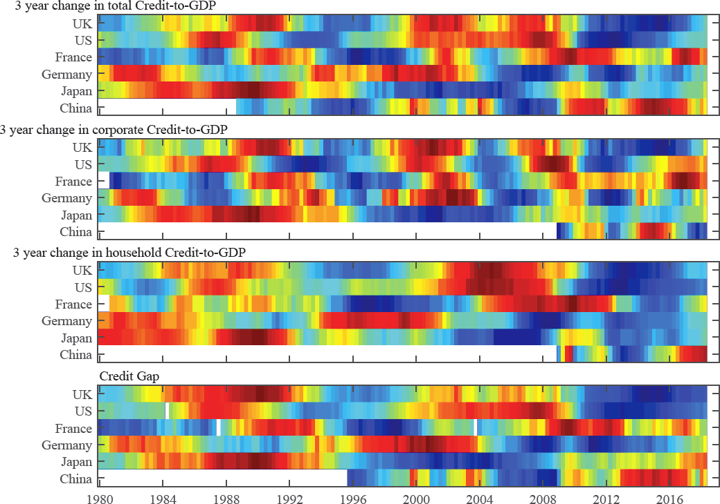

Sources: Bank of International Settlements (BIS) and Bank calculations.

Notes: Each data series included in the heat map has been rescaled into a percentile by using a kernel density estimate of its cumulative distribution function. Red values indicate readings in excess of the 80th percentile; dark blues indicate readings below the 20th percentile; green values are close to the median.

Digging a little deeper, household balance sheets have generally improved. Whereas in the lead-up to the global financial crisis, household debt in the US, UK and major euro-area economies16 rose by almost 40 percentage points relative to income, since then households have delevered by an average of 11 percentage points.17 UK households have gone further, de-levering by about 20 per cent of income. The share of highly indebted UK households has fallen to 1% from a pre-crisis peak of almost 3%. It would take a rise in interest rates of 300bps to bring this share back up to its historical average.18

Corporate debt is more of a concern, particularly in the US.

Like households, companies repaired their balance sheets following the crisis but unlike households, corporates then went back to the well. Relative to earnings, aggregate corporate debt in the US and UK is

16 Germany, France, Italy, Spain and the Netherlands.

17 Household credit growth has been subdued, rising at an annual rate of less than 5% in each of the UK, US and euro area for the past decade, compared to rates of over 12% in the US and UK pre-crisis.

18 Highly indebted households are defined as those with debt servicing ratios of more than 40%.

nearing pre-crisis peaks,19 and the distribution is worsening. In the UK, the share of highly levered companies is above pre-crisis levels. This is despite the very modest growth in investment.

Globally, the average quality of corporate borrowers has deteriorated materially. The share of lower-rated debt in global corporate bond markets has increased significantly over the last 10 years, with BBB-rated bonds now about half of the market compared to just a quarter in 2007.

The global leveraged lending market grew by 21% in 2018, faster than the rate of growth in US subprime mortgages in the run up to the crisis. At $2.3 trillion, the stock of outstanding leveraged loans is double that of subprime in 2007. Leverage of the most indebted issuers has been increasing rapidly (**Chart 8**).

60% of leveraged loans are now covenant-light and most deals have substantial “add backs” of EBITDA.20 These are developments analogous to the “No Doc / No Income” heyday of US subprime.

To add to the sense of déjà vu, growth in leveraged loans has been increasingly driven by securitisation.

**Chart 8**: New leveraged loans to US companies have become riskier

# Average Median Riskiest 25% Total debt to EBITDA

7

6

5

Post-crisis avg

2017

4

# 2018

Source: LCD, an offering of S&P Global Market Intelligence.

Notes: The chart includes leveraged loans issued to US corporate borrowers. Total debt to EBITDA is measured post- issuance and is not adjusted for EBITDA add-backs, which have increased in size and prevalence in recent years.

There are some important differences between leveraged lending today and subprime a decade ago. Non- banks are playing much smaller roles in origination, and ‘skin-in-the-game’ rules had, until recently, aligned

19 In the US, gross corporate debt as a share of annual earnings was 266% in Q3 2018, compared to 262% at the end of 2007. On the same measure UK corporate debt to earnings was 312% in Q3 2018 compared to 336% at the end of the 2007, but excluding the leverage of UK companies in the CRE sector it is above pre-crisis levels (301% in Q3 2018 vs 278% at end-2007). See the Bank of England’s November 2018 *Financial Stability Report* for more details.

20 This compares to the 40% of US mortgages that were issued without full documentation of borrowers’ income in 2006.

incentives between originators and holders. It is regrettable that this requirement has been rolled back in the US, where 85% of Collateralised Loan Obligations (CLOs) are originated.21

Most fundamentally, the main holders of leveraged loans can generally bear the risks. There is no analogue to the thinly capitalised Structured Investment Vehicles (SIVs) who issued short-term commercial paper to hold long-term illiquid sub-prime debt in the run up to the crisis. For CLOs, the riskiest tranches are concentrated in hedge funds, open-ended funds, structured credit funds and CLO managers (**Chart 9**). US banks and insurers own around one third of CLOs (usually the less risky tranches) compared to only 6% for European firms and 2% for UK firms.

**Chart 9**: Estimated holdings of CLOs by global investors

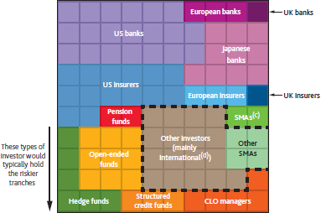

Sources: BarclayHedge, Bloomberg Finance L.P., FCA Alternative Investment Fund Managers Directive (AIFMD), Firm public disclosures, LCD, an offering of S&P Global Market Intelligence, Morningstar, National Association of Insurance Commissioners, Securities Industry and Financial Markets Association, Solvency II submissions, and Bank calculations.

Notes: Indicative estimated holdings of CLOs by global investors. 1 square = 1% of ~US$750 billion global CLO market. For further detail, see footnotes to Chart F. 8 in the November 2018 *Financial Stability Report*.

This specific point highlights the more general progress that has been made improving the resilience of the core of the financial sector. Banks in most regions are now more likely to be stabilisers rather than amplifiers of shocks.

Regulation has made banks less complex and more focused. They lend more to the real economy and less to each other. Trading assets have been cut in half, and interbank lending is down by one-third.

And their resilience in most jurisdictions has been transformed. For example, UK banks have CET1 ratios of about 15%, more than three times their pre-crisis level. Their aggregate MREL is 26%. They hold £1 trillion

21 Based on all widely traded CLOs in the US and Europe.

of high quality liquid assets, a four-fold increase over the past decade. And their short-term wholesale funding has fallen from 15% to 4% of balance sheets.

There is also greater supervisory scrutiny, not least through stringent stress tests. Indeed, in the past few years, major UK banks have been tested against all the major risks I will cover today (from China to inflation scares plus a few others for good measure).

### The Story Thus Far

While there are pockets of risk and global growth is still decelerating, the combination of the policy response and the state of the current imbalances in advanced economies suggest that global growth is more likely than not to stabilise eventually around its new, modest trend.

But this is a judgement, not a guarantee. The world is in a delicate equilibrium. Productivity is weak everywhere. The sustainability of debt burdens depends on interest rates remaining low and global trade remaining open. And business and consumer confidence are being buffeted by extreme policy uncertainty.

Indeed, there are at least three important risks on the horizon.

**First, financial risks will intensify if complacency sets in.** Paradoxically a prolongation of the expansion could make its demise both more likely and more painful.

The frequency of financial crises over history is partly because memories fade, financial lobbies are powerful, and the costs of backsliding on financial reform are invisible, at first.

When it comes to financial stability, success is an orphan.

G20 countries bear heavy responsibilities to safeguard the progress since the crisis through disciplined implementation of agreed reforms. And policymakers must remain vigilant and address new risks as they arise.

The lessons of subprime bear recalling. Subprime mortgages emerged in the mid-1990s as an innovation to expand home ownership to those who had been unfairly excluded. But they eventually grew unchecked until subprime mortgages written in 2006 and 2007 were twice as likely to default as those originated just a few years earlier.

It is just such a descent from responsible to reckless underwriting that we must avoid today. That’s why the FPC has acted to limit the share of high loan-to-income mortgages UK banks can originate, the PRA has tightened standards on consumer credit and the Bank is monitoring closely the growth in leveraged lending.

### The second reason for caution is the possibility of a more material slowdown in China.

China is the one major economy in which all major financial imbalances have materially worsened. It may be the exception that proves the rule that financial imbalances cause recessions.

While China’s economic miracle over the past three decades has been extraordinary, its post-crisis performance has relied increasingly on one of the largest and longest running credit booms ever, with an associated explosion of shadow banking.

Total Social Financing has increased from 120% to 223% of GDP since 2008. In parallel, the non-bank financial sector has increased from around 20% of GDP to over 70% today, with developments echoing those in the pre-crisis US including off-balance sheet vehicles with large maturity mismatches, sharp increases in repo financing, and large contingent liabilities of both borrowers and banks.

Chinese authorities have begun taking measures to manage these risks. Growth in Total Social Financing is now in line with that of nominal GDP (**Chart 10**). The shadow banking sector is being restructured. But there is a tension between reducing the risks from high debt and supporting the economy.

**Chart 10**: Chinese credit growth

Percentage change on a year ago

45

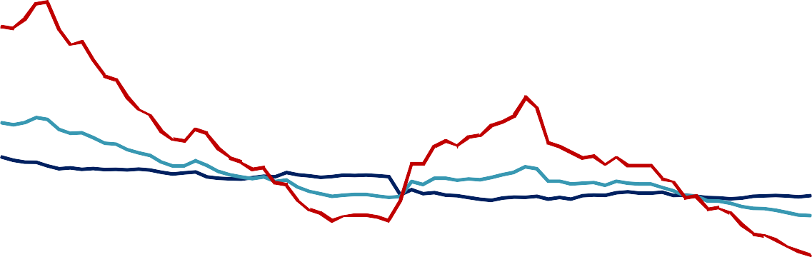

Non-bank

Headline TSF

Bank

Nominal GDP

40

35

30

25

20

15

10

5

0

2013 2014 2015 2016 2017 2018

Sources: CEIC, Datastream from Refinitiv, The People's Bank of China and Bank calculations.

A downturn in the Chinese economy would test the resilience elsewhere. China’s contribution to global growth has risen from one-fifth to one-third since the last US tightening cycle. 22

22 Reflecting the increased importance for China to the global economy, the scenario used in the FPC’s annual stress tests of the major UK banks includes a significant slowdown in the Chinese economy.

To give a sense of the issue, in the 21 credit booms that matched the scale of China’s since 1975, annual growth dropped by 3¼ percentage points on average in the subsequent years. Adjusting for progress thus far and China’s degree of development, this suggests growth could slow a further 1 to 1½ percentage points.

Of course, deeper trade tensions would worsen the slowdown.

The Bank of England estimates that a 3% drop in Chinese GDP would knock one per cent off global activity, including half a per cent off each of UK, US and euro area GDP, through trade, commodities and financial market channels. A harder landing would have significantly larger effects, as these channels would likely be accompanied by negative spillovers to global confidence.

### The final caution concerns the future of globalisation.

Trade tensions abroad and Brexit debates at home are manifestations of fundamental pressures to reorder globalisation. It is possible that new rules of the road will be developed for a more inclusive and resilient global economy. At the same time, there is a risk that countries turn inwards, undercutting growth and prosperity for all. Concerns over this possibility are already impairing investment, jobs and growth, creating a dynamic that could become self-fulfilling.

While the current cycle of globalisation has brought widespread prosperity—lifting a billion people out of poverty and raising output per capita up 40% in both the UK and globally since the mid-1990s—it has also given rise to three imbalances that threaten its sustainability.

*First, external imbalances*, with large trade surpluses emerging in some regions and big deficits in others. Though somewhat smaller than on the eve of the crisis, the sum of current account surpluses remains significant at 2% of global GDP.

The sustainability of these imbalances is made more challenging by the asymmetry at the heart of the international monetary system. As the world economy has been reordered with the weight of emerging market economies rising from 40% to 60% of activity in the past quarter century, the US dollar is as dominant today as it ever was.23 This contributes economically to higher risks of sudden stops and politically to greater mercantilist pressures.

Second, globalisation has contributed to higher *imbalances of income and wealth* in many countries.24 Amongst economists, a belief in free trade is totemic, but while trade makes countries better off, it does not raise all boats within them.

23 For example, two-thirds of official foreign currency reserves are in US dollars, over 60% of countries use the US dollar as their anchor currency, and around half of international trade is invoiced in US dollars - far greater than the US’s 10% share of world trade.

24 The IMF finds that technological progress during the 3rd Industrial Revolution has been the biggest contributor to these increasing imbalances. See IMF (2017), *Understanding the Downward Trend in Labour Income Shares*, April World Economic Outlook, Chapter 3.

Rather, the benefits from trade are unequally spread across individuals and time. Consumers get lower prices and new products, and further benefits from higher productivity over time. Some workers, however, lose their jobs and the dignity of work, or see their “factor prices equalised.” In plain English, their wages fall.

Such dynamics are being felt by those at either end of the great convergence. Survey evidence shows that 70% of Chinese workers believe that trade creates jobs and increases wages, US households think the opposite, and UK public opinion is equivocal.25 The nascent fourth industrial revolution may (for a time) harden such concerns.

And third, globalisation leads to *imbalances of democracy and sovereignty*, leading many to lament a loss of control and to lose trust in the system. As Dani Rodrik has argued, there is a trilemma between economic integration, democracy and sovereignty. 26 Common rules and standards are required for trade in goods, services and capital, but those rules cede or, at best pool, sovereignty. To maintain legitimacy, the process of agreeing those standards needs to be rooted in democratic accountability.

Much will be required to create a more inclusive, sustainable globalisation but part of the solution is a more flexible and open trading system for services and for small and medium enterprises (SMEs).

Freer trade in services can help to resolve external imbalances.27 With barriers to services trade currently up to three times higher than those for goods, the Bank estimates that eliminating this differential could reduce the excess deficits of the US by up to one third and of the UK by up to one half.

Freer trade for SMEs and services would spread the benefits of global markets much more widely than traditional, more multinational-based free trade in goods. SMEs employ 60% of workers. More women work in services than men. The digital revolution28 could help to ensure trade is available to the smallest companies as well as the largest.

And freer trade in services could help rebalance the trilemma from prescriptive supranational rules to more differentiated, national approaches to achieve common outcomes.

The post-crisis reforms of financial services offer a model. The G20 has agreed a wide range of regulatory standards and put in place the mechanisms for deep supervisory cooperation. These Financial Stability Board (FSB) reforms create a platform for cross border financial services between different legal systems and regulatory approaches that achieve similar outcomes for financial stability. This avoids unnecessary

25 See Carney, M (2016), ‘The Spectre of Monetarism’.

26 Rodrik, D. (2011). The globalization paradox: Democracy and the future of the world economy.

27 See Carney, M (2017), ‘A Fine Balance’.

28 Sales are increasingly taking place on-line and over platforms, rather than on the high street. Intangible capital is now more important than physical capital. A hyper-connected, capital-light world, could offers a future that increasingly belongs to small and medium-sized firms, with platforms (such as taskrabbit, Amazon, Etsy, Shopify, and SamaHub) giving them direct stakes in local and global markets.

duplication and costly fragmentation while promoting greater competition, enhanced resilience and improved efficiency to the benefit of all our citizens.

### Conclusion: Is this How the Expansion Ends?

Although the economic and financial imbalances in the global economy do not yet appear to contain the seeds of their own demise, global momentum is softening.

Monetary policymakers may need to be disciplined and macroprudential authorities, vigilant.

Risks from China and from de-globalisation are significant and growing. Could they be how the expansion ends?

Protectionism appears already to be having an impact. Last year trade growth lagged the growth of global activity, and current global export PMIs now signal a contraction in global trade (**Chart 11**).

**Chart 11**: Trade growth has weakened notably

56 Diffusion Index, 50 = no change 55

54

Global manufacturing PMI:

53 New export orders (6 month lead, LHS) 52

51

50

49

48

47

46

Percentage change on a year ago 7

CPB world trade volume 6

(3 month MA, RHS) 5

4

3

2

1

0

-1

-2

2011 2012 2013 2014 2015 2016 2017 2018 2019

Sources: CPB,Markit Economics and Bank calculations.

Bank of England simulations suggest that the impact through direct trade channels of the narrow, bilateral tariffs already announced would tend to be small and would be largely confined to the countries directly involved.

A larger increase in tariffs of 10 percentage points between the US and all of its trading partners could take 2½ per cent off US output and 1 per cent off global output through trade channels alone, although the impact on the UK is smaller reflecting a greater exchange-rate driven boost to net exports. If business confidence and financial conditions are also affected (as recent experience suggests they would be), these impacts could double (**Table 2**).

**Table 2**: GDP losses from a 10 percentage point increase in tariffs on US trade would be substantial29

|  |  |  |  |  |
| --- | --- | --- | --- | --- |
| GDP impact (peak impact over three year period, %) | US | UK | EA | World (PPP) |
| Trade war | - 2½ | -½ | -1 | -1¼ |
| Tighter financial conditions | -1 | -1 | -¾ | -½ |
| Greater uncertainty | -½ | -¼ | -¼ | -¼ |
| Permanent tariffs | -¾ | 0 | -½ | -½ |
| Total | -5 | -1¾ | -2¼ | - 2½ |

Notes: Bank calculations.

There are signs that concerns about such possibilities are beginning to cascade through economies via reduced investment and demand.

Consider the UK as a leading indicator of a nascent global trend. UK business investment has fallen 3.7% over the past year despite the ongoing expansion, high business profitability and accommodative financial conditions. With fundamental uncertainty about future market access, UK investment hasn’t grown since the referendum was called and has dramatically underperformed both history and peers (**Charts 12 and 13**).

**Chart 12**: The recovery in UK business investment has stalled since the EU referendum

Indices: peak in GDP = 100 180

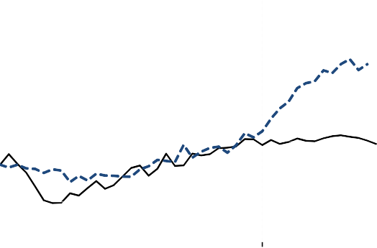

Average

Range of previous recessions

2008

EU

Referendum Act

160

140

120

100

80

60

0 5 10 15 20 25 30 35 40

Quarters since pre-recession peak in GDP

**Chart 13**: UK business investment growth has fallen below other advanced economies

Four-quarter growth (%) 20

Range of G7 countries excl. UK

UK

15

10

5

0

-5

-10

-15

-20

-25

2007 2008 2009 2010 2011 2012 2013 2014 2015 2016 2017 2018

Sources: ONS and Bank calculations. Sources: Eikon from Refinitiv, Japanese Cabinet Office, OECD, ONS, Oxford Economics, Statistics Canada, US Bureau of Economic Analysis and Bank calculations.

Similarly, a prolongation of global trade uncertainty could undermine the global expansion. The impact would be magnified if financial markets move such a possibility from their tail risks towards their central scenarios.30

29 Based on simulations using NiGEM. The baseline scenario assumes a 10 percentage point increase in tariffs that persists for three years. The additional impact from tighter financial conditions is based on a 75bp increase in term premia and 50bp increase in equity risk premia globally; and the uncertainty impact is proxied by assuming agents anticipate a further 10pp increase in tariffs the following year. Global monetary policy is held fixed for five years.

Most fundamentally, the larger and the more permanent the disruption to global trade—the greater the de- globalisation—the greater the reduction in both activity and supply capacity of economies. The latter—a material hit to supply—is something that advanced economies have not experienced since the mid-1970s.

In this scenario, the combination of slower growth, smaller surpluses in Asia and higher risk premia could move global interest rates higher, increasing the burden of corporate and household debts and challenging the creditworthiness of some sovereigns.

Contrary to what you might have heard, it isn’t easy to win a trade war.

If the UK has been somewhat more inwardly focused of late, it has been for good reason.

In many respects, Brexit is the first test of a new global order and could prove the acid test of whether a way can be found to broaden the benefits of openness while enhancing democratic accountability. Brexit can lead to a new form of international cooperation and cross-border commerce built on a better balance of local and supranational authorities. In these respects, Brexit could affect both the short and long-term global outlooks.

It is in the interests of everyone, arguably everywhere – from Frobisher’s grave to Frobisher’s Bay - that a Brexit solution that works for all is found in the weeks ahead.

30 While economic, policy and geopolitical uncertainties are very high, several market-based risk metrics are not. Credit spreads, the VIX and equity implied volatilities are below the 50th percentile of their historic distributions, as is equity risk premium in the US. Despite recent volatility, high-yield corporate bond spreads also remain below pre-crisis averages.

**ANNEX**

**Table A1**: Weighted average bilateral tariffs

|  |  |  |  |  |
| --- | --- | --- | --- | --- |
| Tariffs imposed by:  On imports from: | US  China | China  the US | US  the EU | EU  the US |
| Prior to recent escalation | 2.6 | 9.1 | 3.3 | 3.0 |
| Current measures(a) | 8.4 | 17.8 | 3.7 | 3.3 |
| With contemplated measures(b) | 13.7 | 22.4 | 6.7 | 7.7 |

1. US tariffs on steel and aluminium, the reciprocated tariffs of 25% on $50bn of US imports from China, and 10% tariffs on an additional $200bn of US imports from China, matched by 10% tariffs on $60bn US exports to China.
2. The contemplated hike in the tariff on $200bn of US imports from China from 10% to 25%, reciprocation by China on US exports of $60bn, and the potential US tariffs on EU motor vehicles and parts.

Notes: Bank calculations.